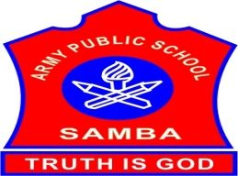
ARMY PUBLIC SCHOOL SAMBA
WEEKLY REPORT
AUGUST 21,2023-AUGUST 26,2023

SCHOOL EVENTS

PERIODIC TEST-I FOR CLASS XI (AUGUST 21-26,2023)
Periodic Test-I for class XI was conducted from August 21-26,2023 at APS Samba.

INTER HOUSE ENGLISH DEBATE COMPETITION (VI-VIII) (AUGUST 25,2023)
An Inter House English Debate Competition was organized for the students of classes VI-VIII on August 25,2023 on the topic – “Books Provide Better Entertainment Than Television”.There were three participants from each House, one speaking for the motion, one speaking against the motion and one interjector. All the speakers put forth strong and well-grounded arguments to prove their points.Interjectors also raised very logical questions. The speakers answered very confidently, backed with rational examples or instances.The result of the competition is as follows:
Best speaker: Daksh VII A, Best Interjector: Snathia VI E
HOUSE POSITIONS
FIRST- TERESA HOUSE
SECOND- NEHRU HOUSE
THIRD: SAROJINI HOUSE
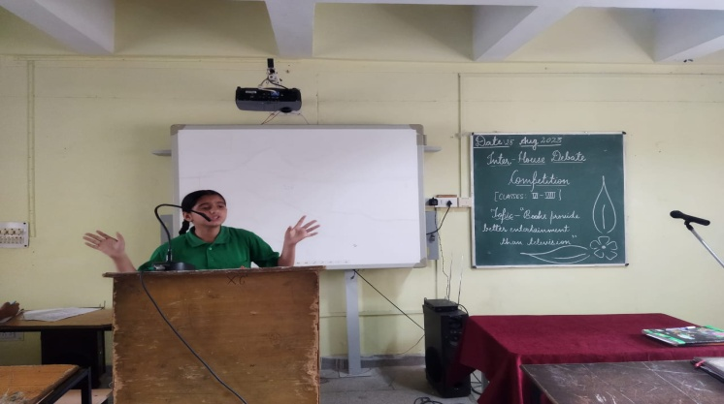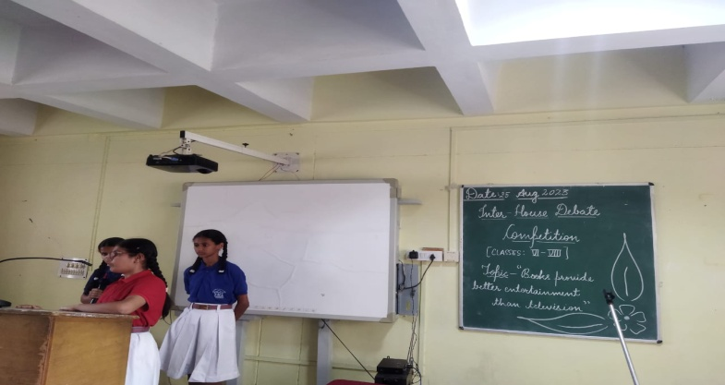

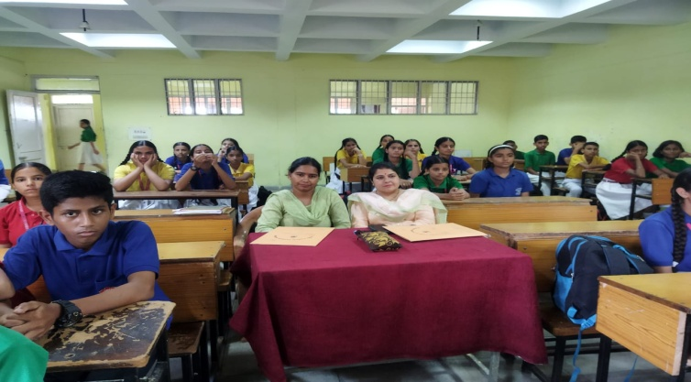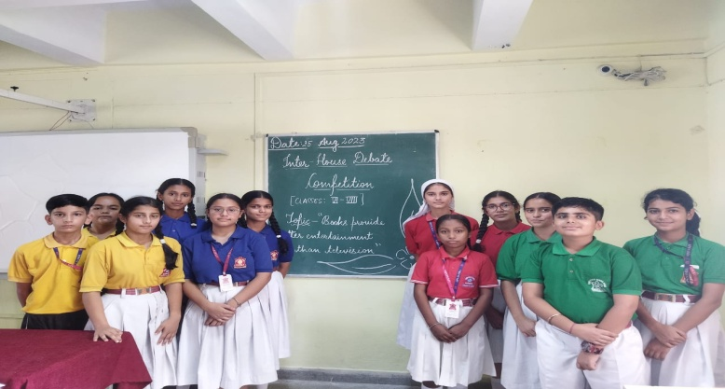
ART OF LIVING SESSIONS FOR STUDENTS OF CLASSES VIII-XII (AUGUST 25,2023)
To enhance intuition,confidence and to boost creativity and intelligence amongst students,the teachers and volunteers from ‘Art of Living’ conducted sessions for the students of classes VIII-XII at APS Samba on August 25, 2023.Meaning of proactive approach to life and significance of Meditation was also explained to them in these sessions.Students actively participated in the sessions.Total 26 students from the school gave willingness to attend the sessions in future and deposited the fee.

NIAS-ALC OFFLINE SESSION (AUGUST 23,2023)
Offline session of NIAS- ALC was conducted on August 23,2023.The topic of discussion for the class was- “ Creating stories using scratch 2.0/3.0. Class was fully interactive and students took part in the discussion with great interest.
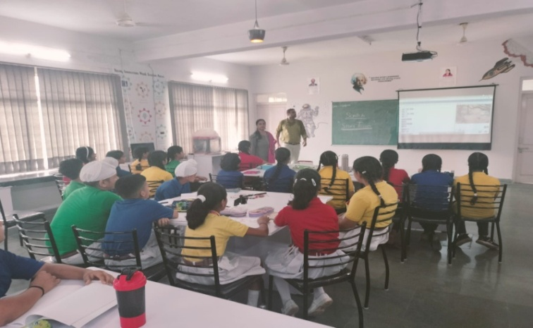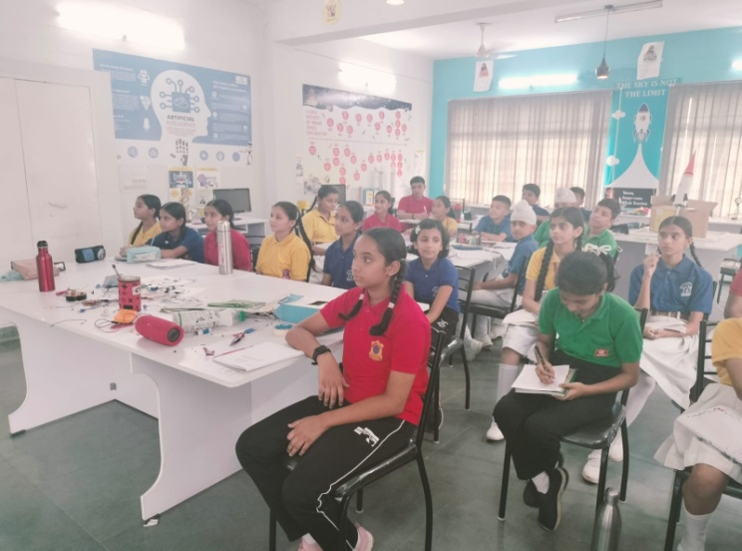

ARYABHATTA GANIT CHALLENGE 2023-REGISTRATION (AUGUST 21-24,2023)
To enhance the mathematical abilities of the students,the registration process for ‘Aryabhata Ganit Challenge’ was held at APS Samba from August 21-24,2023.The students from classes VIII-XII registered themselves for the same.

RAKHI CELEBRATION (AUGUST 25,2023)
To mark the celebration of Raksha bandhan,various competitions were organized for the students of classes I-V on August 25,2023 at APS Samba:
CLASS I & II – English Poem Recitation
CLASS III- Rakhi Making
CLASS IV-Book Mark Making
CLASS V- Pen Holder Making
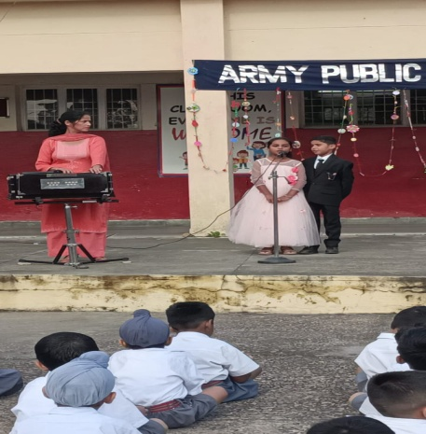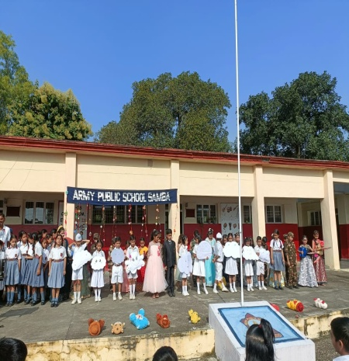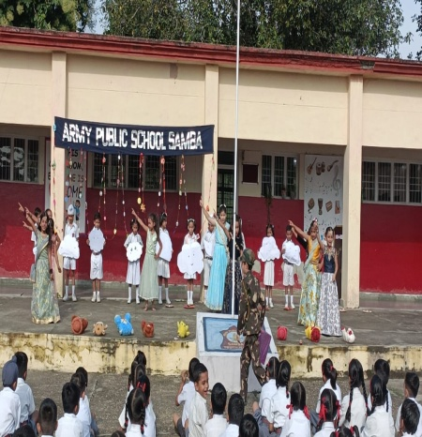

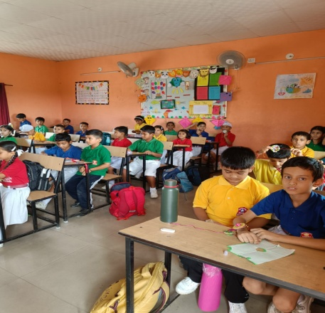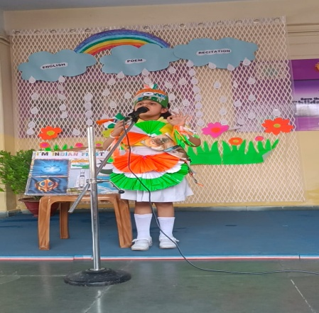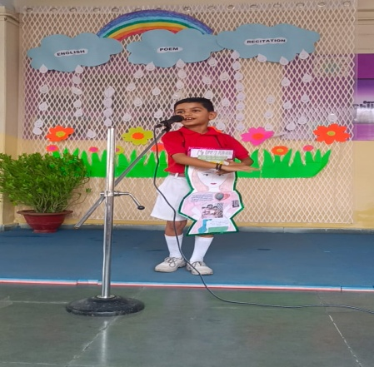
WORKSHOP ON POSITIVE REINFORCEMENT ( AUGUST 26,2023)
A workshop on ‘Positive Reinforcement’ for the Primary Teachers was conducted by Ms Avneet Kour, PRT on August 26,2023 at APS Samba.

THANK YOU

